AI ROAST GENERATOR

BUG 1 – Won’t take full name
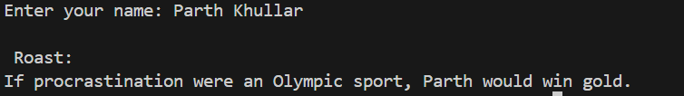
Prompt - My C++ program is not taking full name as input. If I enter "Parth Khullar", it only takes "Parth".
Fix this issue.
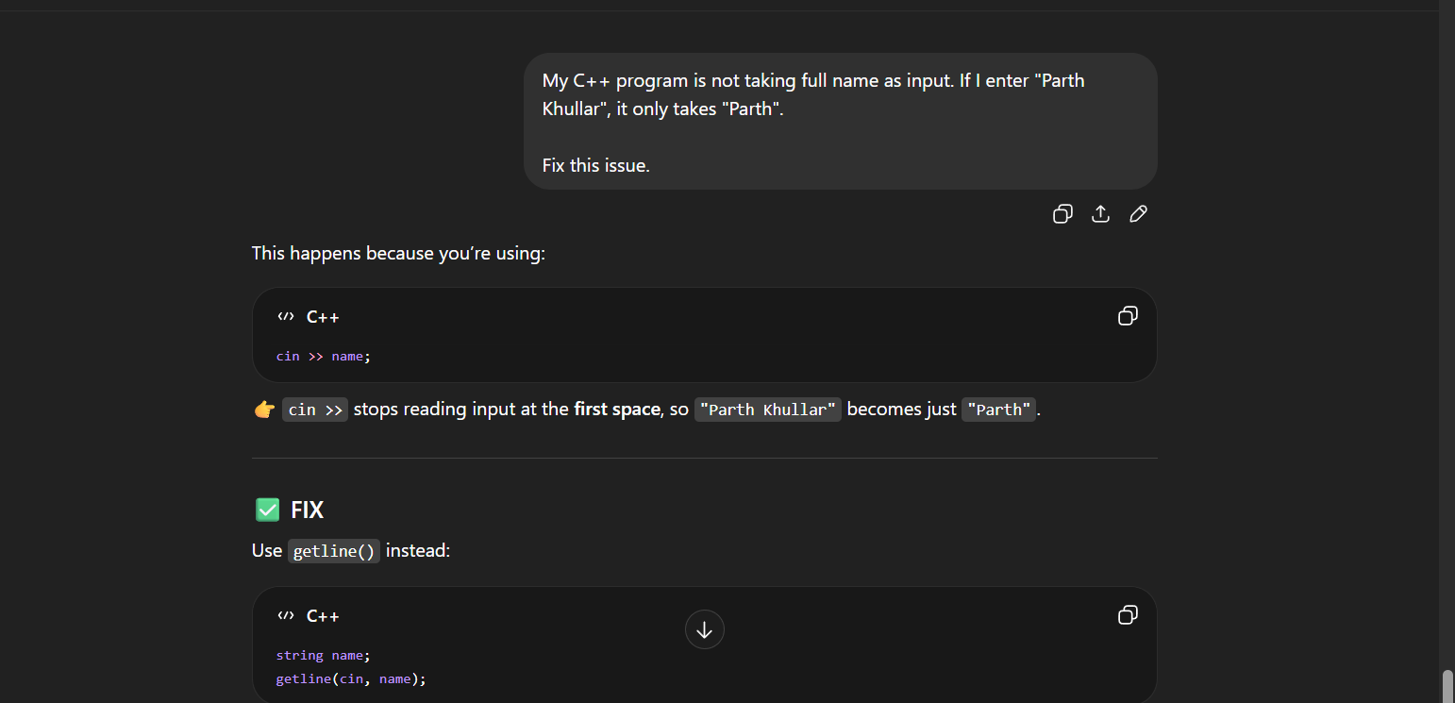
After Correction - 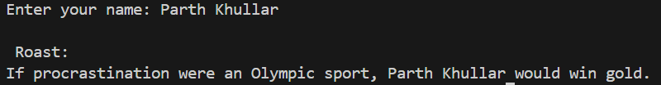

BUG 2 – No check for empty input
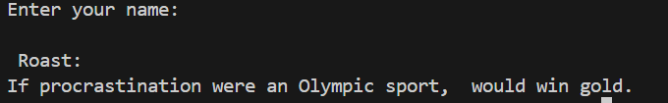
Prompt - My C++ program is also working on Empty input , it should have given error but still prints with blank input . Fix this issue
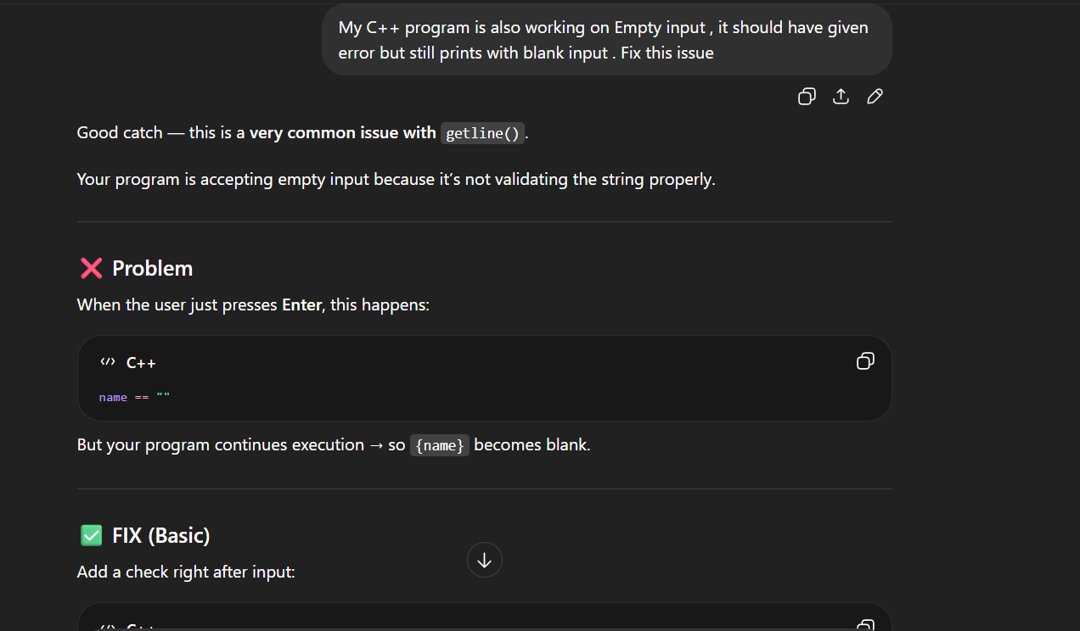
After Correction –
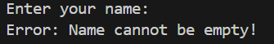
BUG 3 – Same roast every time
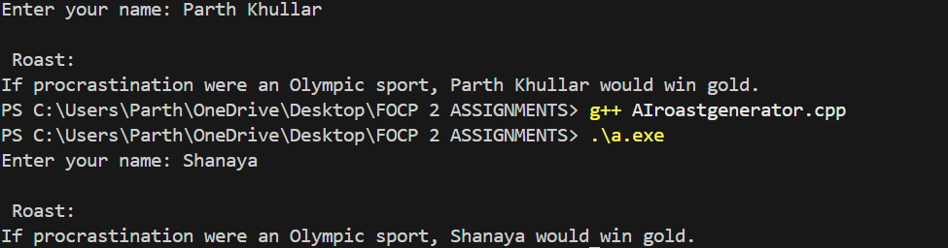
Prompt - My C++ program gives the same random output every time I run it.
Fix the issue and explain why it is happening.
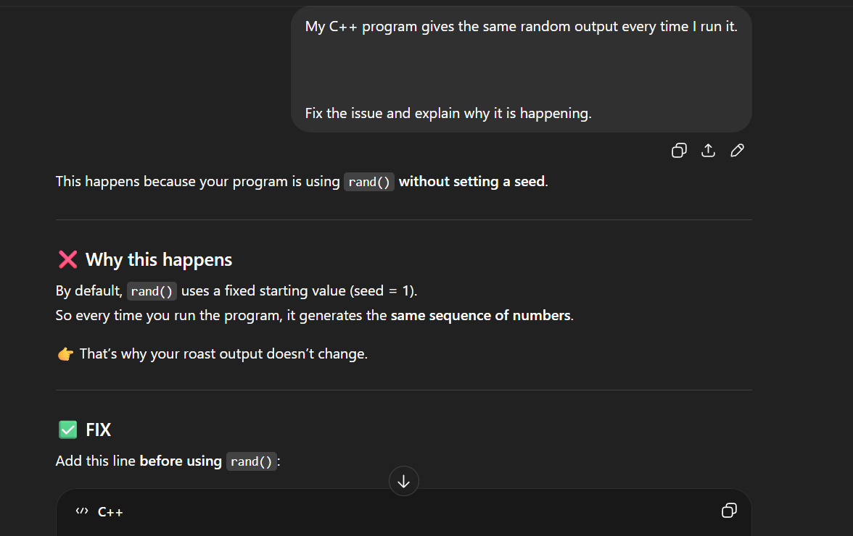
After Correction –
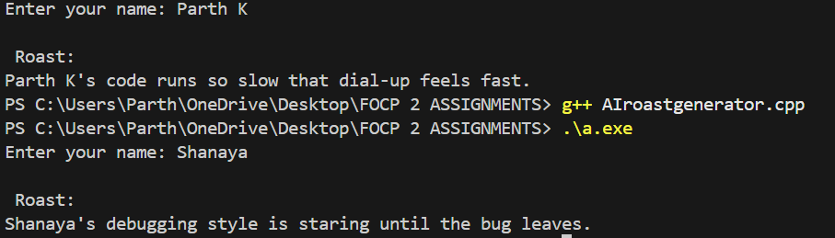
BUG 4 – Only replaces first occurrences of the name
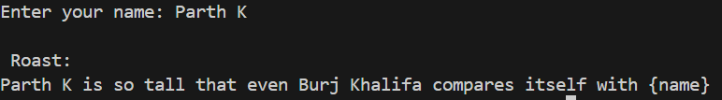
Prompt - Correct the name occurrences error
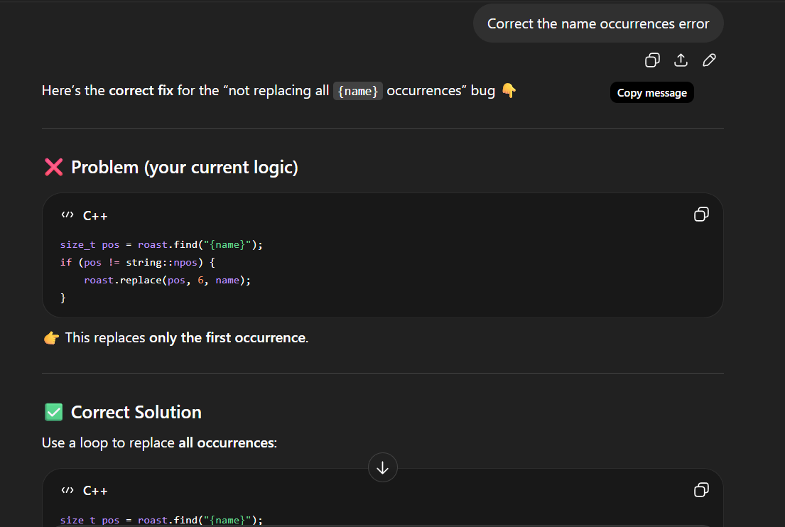
After Correction –
